**Institute Of Space Technology**

**Street light System**

**Project Report**

**Embedded Systems**

**Submitted by:**

**Shahrukh**

**Email:** [**khan.shahrukh8910@gmail.com**](mailto:khan.shahrukh8910@gmail.com)

**Contact: +923173487167**

Table of Contents

For Speaker

* Background Information_________________________________2
* High pass filter.________________________________________4
* LM358N_____________________________________________5
* Clamper_____________________________________________6
* Potentiometer_________________________________________7
* 1N4148______________________________________________7
* LM386N-3____________________________________________8
* Snoober Circuit_______________________________________10
* Speaker_____________________________________________11
* Circuit Diagrame______________________________________12
* Working of Whole Circuit________________________________12

For Microphone

* Microphone__________________________________________12
* Voltage Divider_______________________________________13
* LF353N_____________________________________________15
* Gain Variable________________________________________16
* Circuit Diagrame______________________________________17
* Working of Whole Circuit _______________________________17
* Practicle Circuit_______________________________________18

**Speaker**

**Background Information:**

Audio speakers convert electrical signals into mechanical motion. The most common

speakers for high-quality audio are constructed as shown in Figure 1-3. The electric signal is

passed through a coil of wire (the “voice” coil), which is suspended a strong magnetic field

provided by a permanent magnet. A time-varying current in the coil leads to a mechanical

deflection relative to the magnet. The coil is attached to a lightweight conical membrane

(Usually made from a heavy-grade paper) that couples the mechanical motion of the coil to the surrounding air molecules.

 

Speakers are commonly specified by their frequency response, impedance level, and

power-handling capacity. Typical speaker impedances are “8” or “4” or “16”. This is

often a source of confusion because it suggests the speaker is modeled by a constant

resistance of this value. In reality there is a significant reactive component of impedance and

hence a strong variation of impedance with frequency, as shown in the figure above. The

impedance can also depend strongly on the surroundings. For example, a speaker measured in

isolation (the “free-air” response) will have a different impedance than one mounted in a

wooden enclosure.

**High pass filter:**

The definition of high pass filter is a filter which passes only those signals whose frequencies are higher than cutoff frequencies thereby attenuating signals of lower frequencies. The value of cutoff frequency depends on the design of the filter.

Cutoff frequency = 1/2πRC

High pass filters which we used in our circuit:

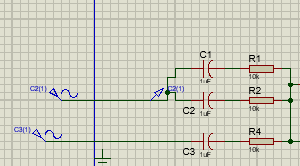

**Output At High pass filter:**

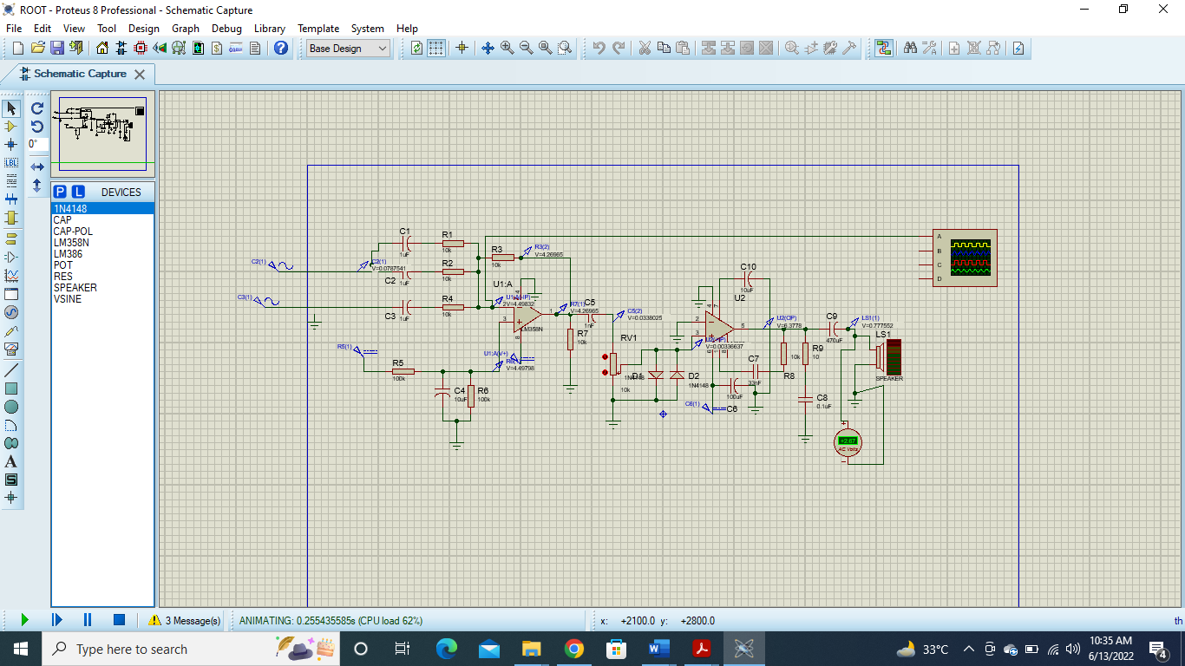

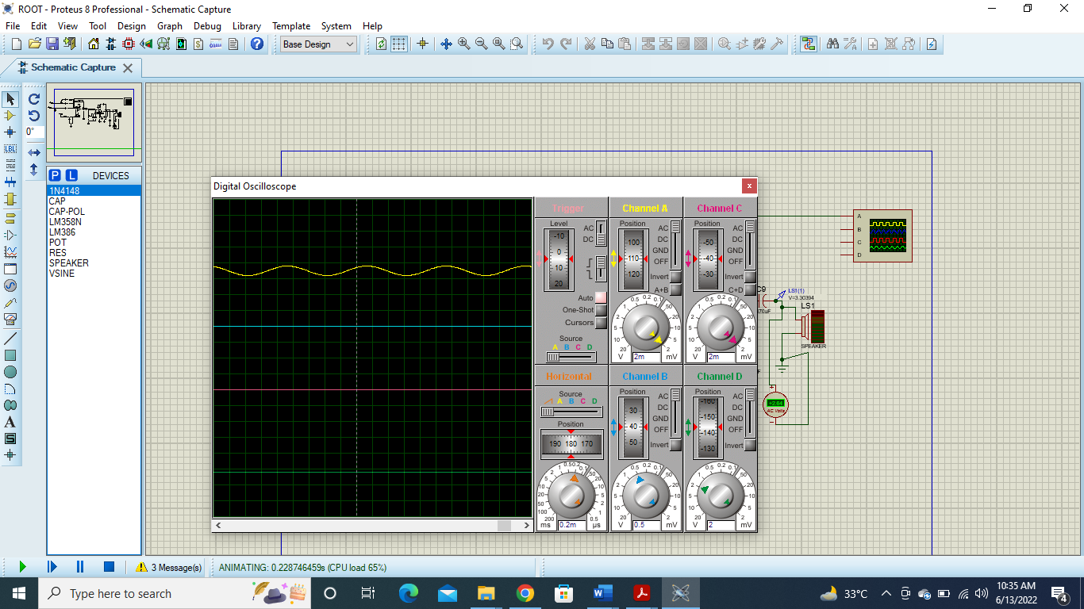

**LM358N:**

For the remainder of the circuit (a simple unit-gain summing network) we have chosen an LM358 op-amp, which is a low-power device that can be operated from a single voltage supply, therefore appropriate for battery-operated circuits. Low-power op-amps draw very little quiescent current and hence help prolong the life of the battery.

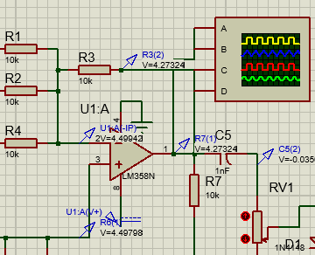

**Output At LM358-N:**

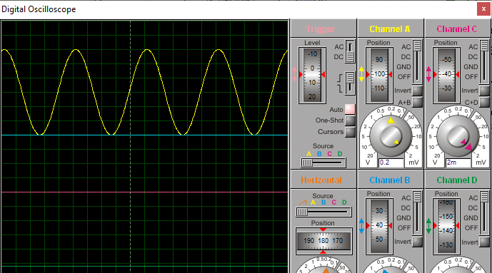

**Clamper Circiut:**

Clamper circuits are the electronic circuits that shift the dc level of the AC signal. Clampers are also known as DC voltage restorers or level shifter. Clampers are basically classified as positive and negative that includes both biased and unbiased conditions individually.

In our circuit:

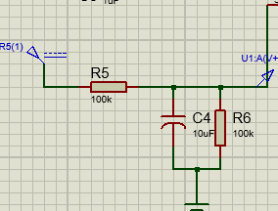

In our circuit we gave 9v to LM358-N. now we don’t want to clamp the negative value of 9v so we connect the clamper circuit which shift the DC level to 4.5.

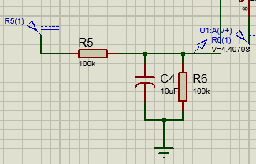

**Potentiometer:**

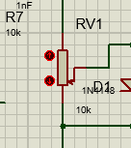

Potentiometer is a variable resistor through which you can control the input Voltage and control valume on the speaker by varying it..Here we use 10k Potentiometer so we can control input to the LM386.

**1N4148:**

It is Diode which allow flow of voltage in one direction

In our circuit we use two diodes one for Positive cycle of voltage and one for negative cycle.

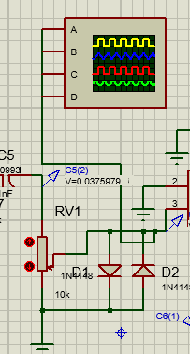

Now when the voltage is greater than 0.7 then the diode will short and will provide a path for voltage with ground and when voltage is less than 0.7 then the diode will act as open circuit .

**Output from diode:**

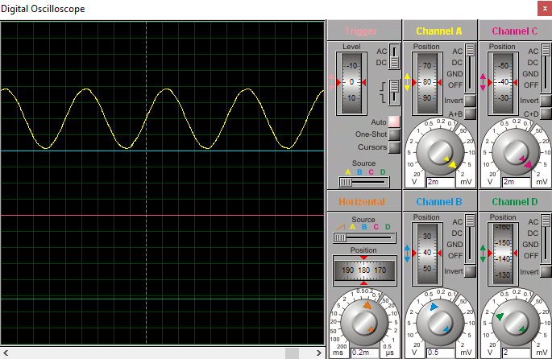

**LM386N:**

At first glance this project looks simple; all we need is an amplifier to drive an audio speaker,

right? Why not just use a simple op-amp gain stage? Well, one immediate challenge is that

speakers have a low impedance, typically 8-Ohm. Even for a low-power 0.5W audio

amplifier, *P*  *I* 2*R*/ 2 requires that the amplifier must be able to source a peak AC current of

around 350 mA with an 8-Ohm load. This is a lot more than a typical op-amp is designed to

provide. For example, the LM358 and LF353 (two op-amps used in this lab) can source

around 20-40mA at most. So we need a device that can handle higher currents. We also

want a device that can be operated from a single supply voltage (a battery in this case).

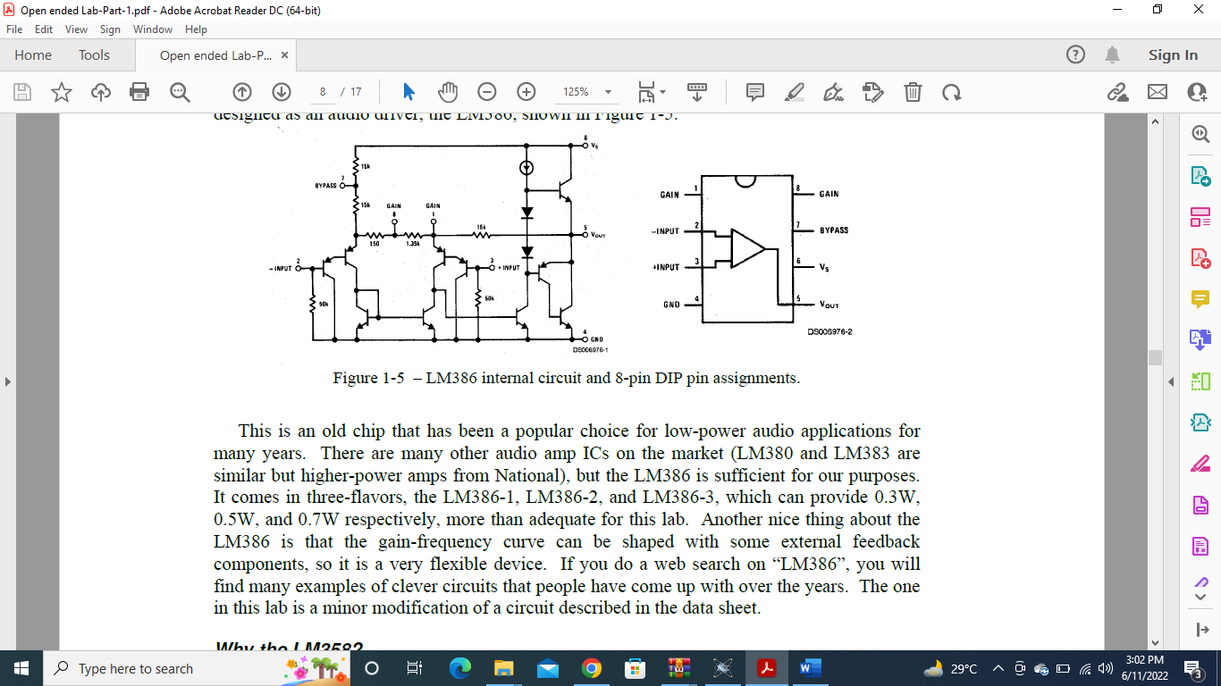

In our circuit:

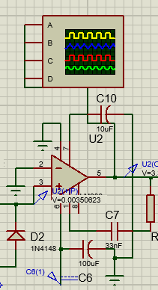

**Output:**

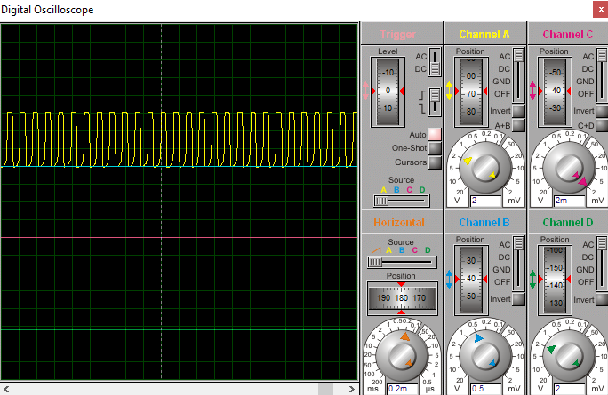

**Snubber Circuit:**

An output snubber is an RC network placed at the output of a switching audio amplifier. The snubber dampens any ringing or overshoot on the PWM output waveform. The stray inductance in the IC leads, IC bond wires, and PCB traces causes the overshoot and ringing.(It avoid the fluctuation of the signal)

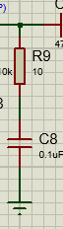

**Speaker:**

Speaker is used to hear the Amplified analogue signal.

It require some voltage so that we can hear the amplified voltage.

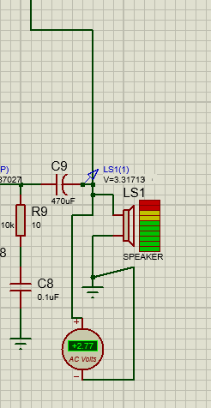

**Output :**

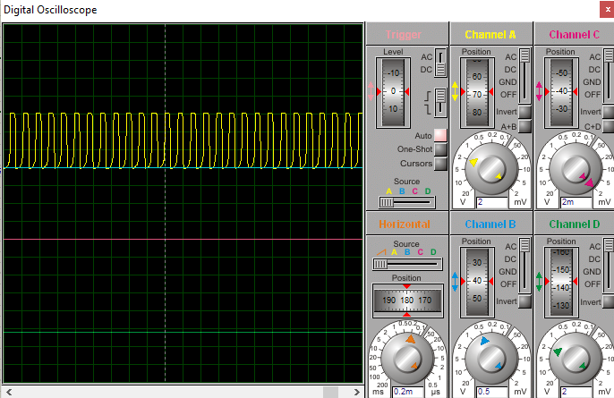

**Circuit Diagrame :**

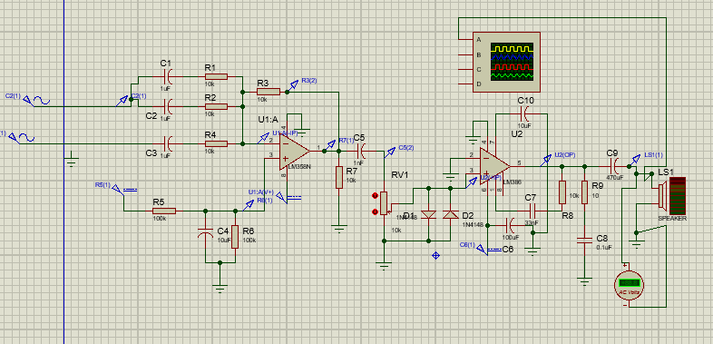

**Working Of Whole Circuit:**

First of all summing network, which is used to combine several audio inputsinto a common output signal ,Combine the signal at a common out put point.Now the lower clamper circuit set the reference DC line at 4.5v .the C5 capacitor block the dc signal .The R7 provide a path to ground for the block dc values.the potentiometer limit the input voltage.the diodes on allow voltage from 0 to 0.6 to the LM386 ic because it’s a low input ic.next the combination of C7 and R8 control the bass of amplified voltage.The snubber circuit prevent the signal from fluctuation.

**For Microphone**

**Microphones**

A speaker can be used in reverse to create a microphone. In the case the incoming sound

wave leads to a mechanical deflection of the cone and voice-coil. According to Faraday’s

law, a time-varying current will be induced because the coil is moving in through a magnetic

field (produced by the permanent magnet). Although any speaker could be used for a

microphone, most speakers are unnecessarily large for this purpose, except in simple

intercom applications where it is common to use the same component to perform both the

speaker and microphone functions. Another type of microphone is the “condenser” microphone, which exploits electrostatic

forces instead of magnetic induction. The “cone” in this case is a thin metallic membrane

that forms one side of a parallel-plate capacitor (***condenser*** is an old-fashioned term for

capacitor). An incoming sound

wave causes the membrane to

vibrate and hence the capacitance

changes. If the capacitor is

charged through an external pullup

resistor as shown in Figure

1-2a, the time-varying capacitance

will induce a time-varying current

through the resistor and hence an

AC voltage.

An especially popular type of

condenser microphone today is

the “electret condenser” variety in Figure 1-2b. In this case the time-varying capacitance is

used to modulate the gate voltage on a built-in FET, which buffers and amplifies the signal.

The capacitance is constructed from an electret material that has a permanent polarization or fixed charge, hence it is not necessary to bias the capacitor as in a conventional condensermic, but of course the FET buffer *does* require biasing.

**Voltage divider:**

In electronics, a voltage divider is a passive linear circuit that produces an output voltage that is a fraction of its input voltage. Voltage division is the result of distributing the input voltage among the components of the divider.In our circuit their required 6v for the IC so we use the voltage divider.

In our circuit:

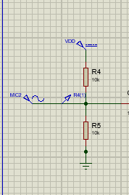

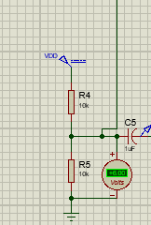

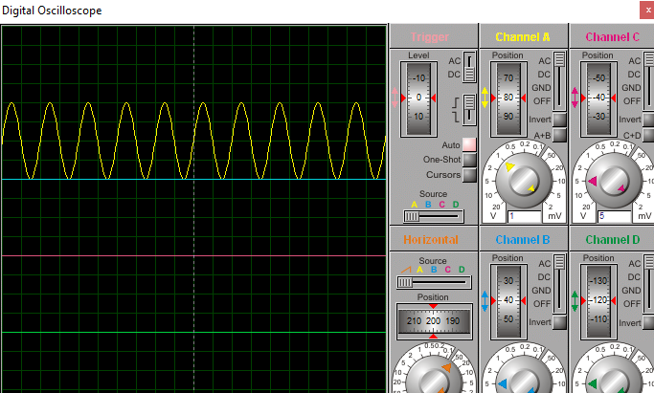

**LF353N:**

The LF353N op-amps are mainly used in high-speed integrators, Digital to Analog converters, sample and hold circuits, and many other circuits with high input impedance and low input bias current. These types of devices produce low noise with offset drift voltage.

In our circuit:

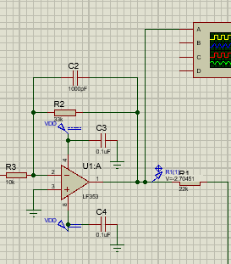

It is amplifying the inpu voltage coming on inverting voltage of middle frequency .if the frequency is too high then it will go through the C2 without amplifying.

**Output At LF353N:**

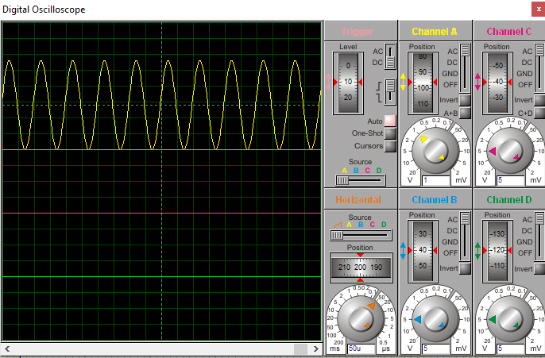

**Gain Variable:**

Here we use potentiometer as a gain variable. We can adjust the gain of output through this potentiometer.

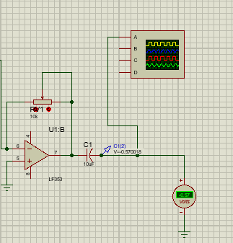

**Output:**

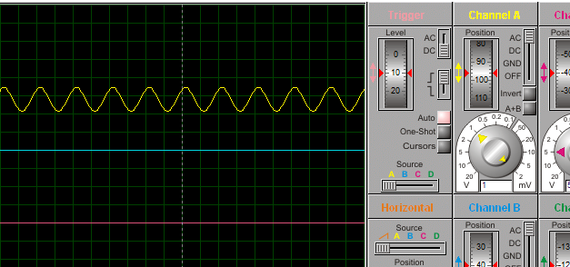

**Circuit Diagrame :**

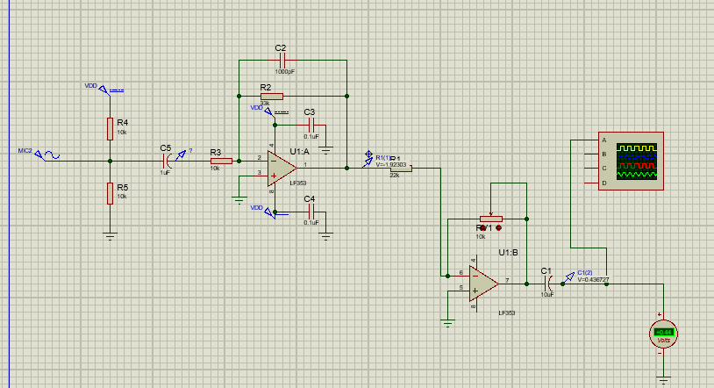

**Working of Circuit as a Whole:**

In this circuit first of all the voltage is divided by the voltage divider which according to the requirement of LM353.The the C5 block the DC voltage .Now the voltage is amplified by the LM353 which .If the frequency of the input which is given to to LM353 is high the it will pas through the C2 without amplifying.now the amplified signal is given to the 2nd LM353 which will again amplify the input voltage according to the set by the user through potentiometer.

**Practical Circuit:** 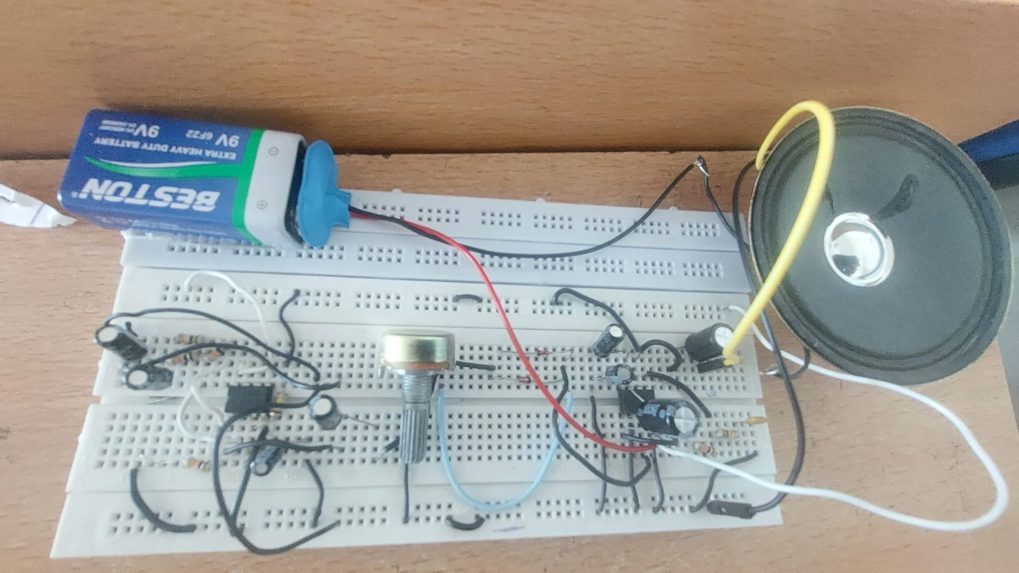

**Conclusion:**

We concluded the following from this lab:

* We have learned that how to construct microphone and speaker.
* We understand it’s working.
* We also came to know the use of coupling capacitor
* We understand the working of OP Amps.
* We also understand the working of snoober circuit.
* We came to know the working of LM368N and LM353N
* We learnt how to make an audio amplifier also we learnt how to make the audio amplifier with microphone as well as speaker.
* Dealt with many distortions in the sound however improved it by trying different values capacitors.
* Practically used clamper circuits, high pass filters and snubber circuits.

**THE END**